**Employee Management system**

**SPRINT-1**

**1)Login Page:** With the login screen **user** can login on different role for example employee /admin/ manager

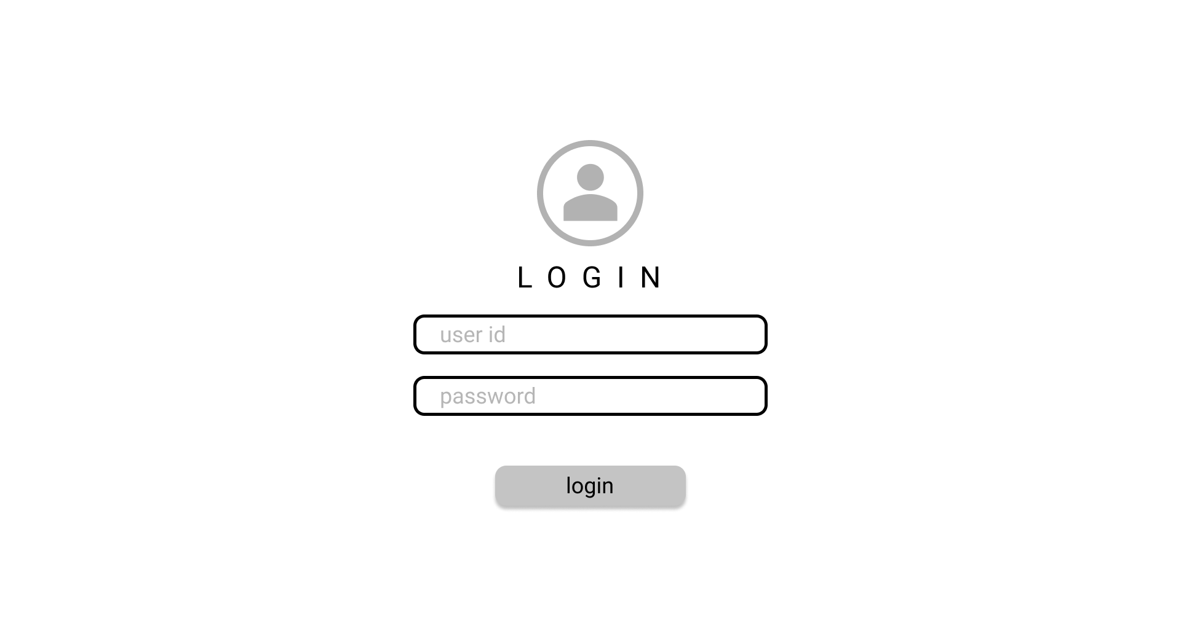

**2)Admin Page:** From Admin Page, Admin can add new employee,can view employee detail, can edit employee details, And there is feature to respond o leave request, resource request. Admin can create new project,Assign project to manager and monitor progress of it.

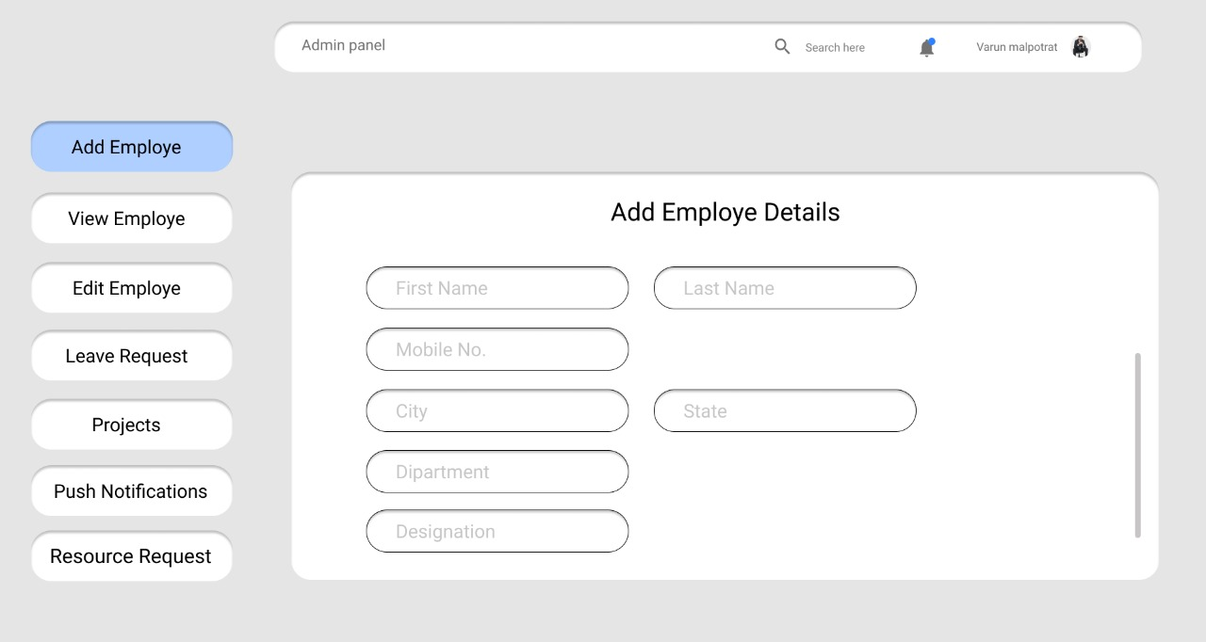

**3)Manager Page:** With the manager page ,Manager can monitor Assigned project, create new issues and assign employee to that issue and can check the status of issue. Manager can Accept /Decline the request of leave came from employee. Manager can request resource to admin .

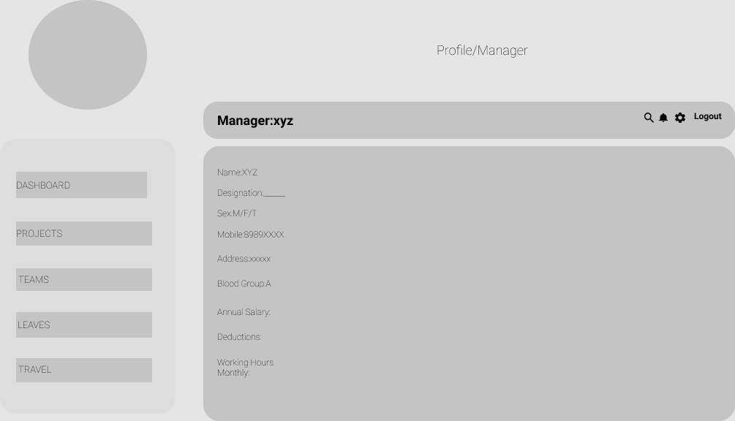

**4)Employee Page:** With the Employee Login, Employee can see pending issues of dashboard And Today’s Task. Employee can see their profile and edit some information. Employee can request for leave . Employee can see project team and can connect to team members.

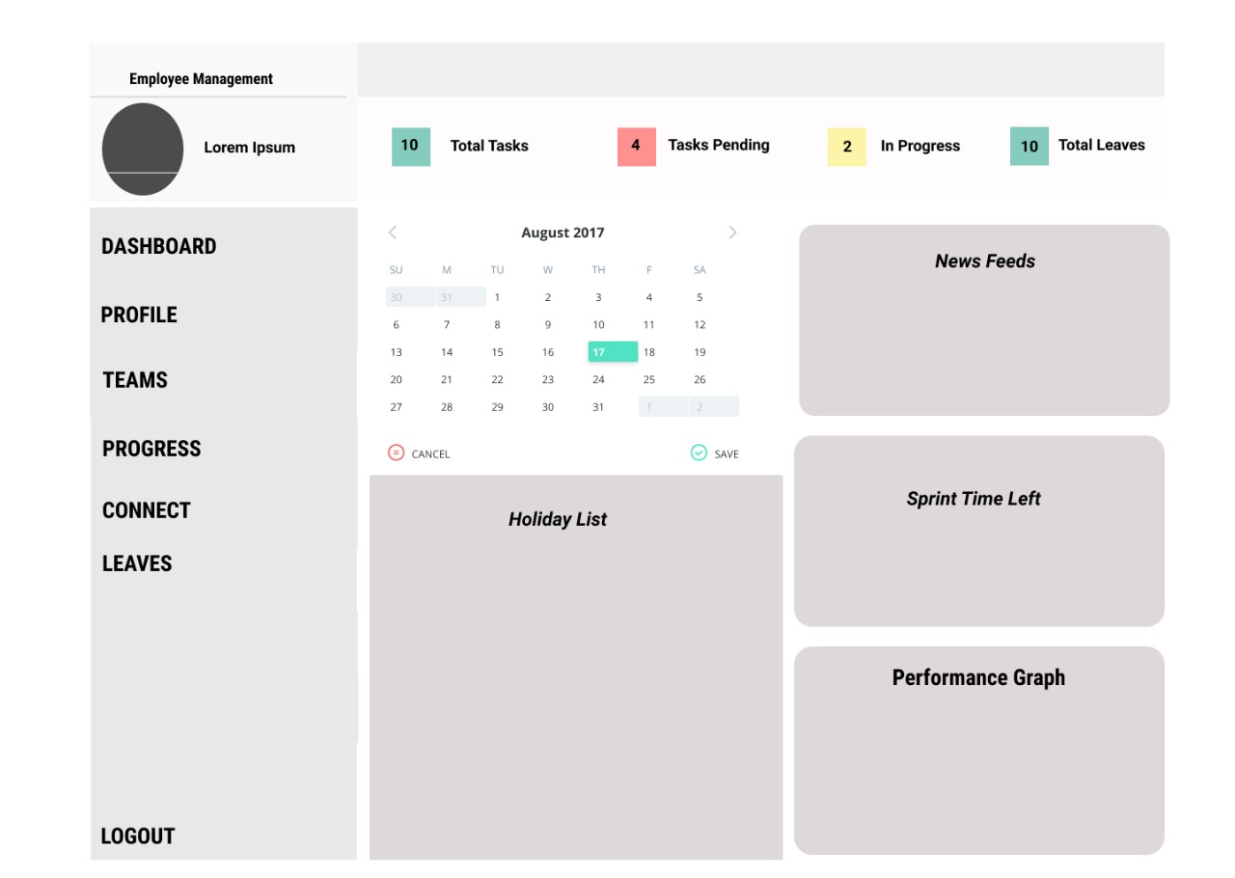

**SPRINT-2**

**1)Admin Page:**

**A01:-**Admin can add new employee.



**A02:-** Admin can view all employee.

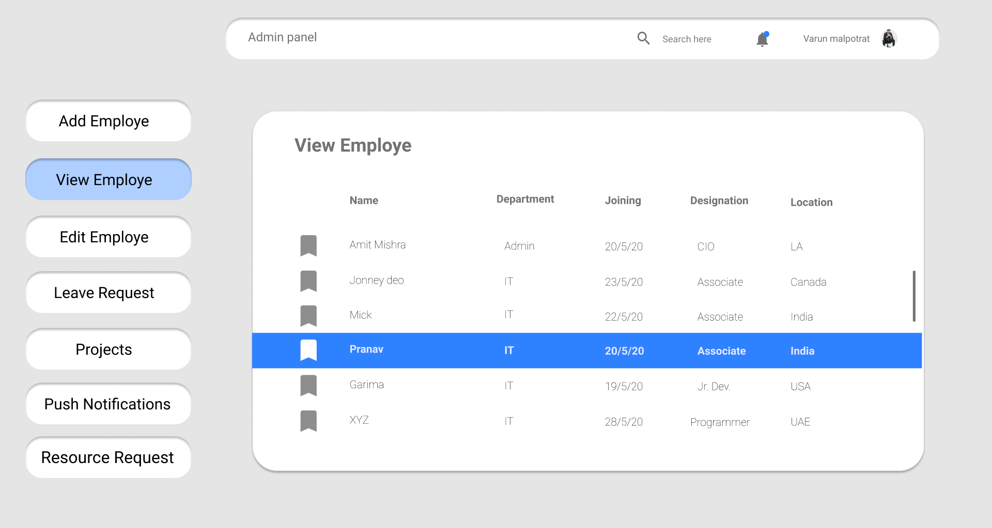

**A03:-** Admin can Edit employee Information.

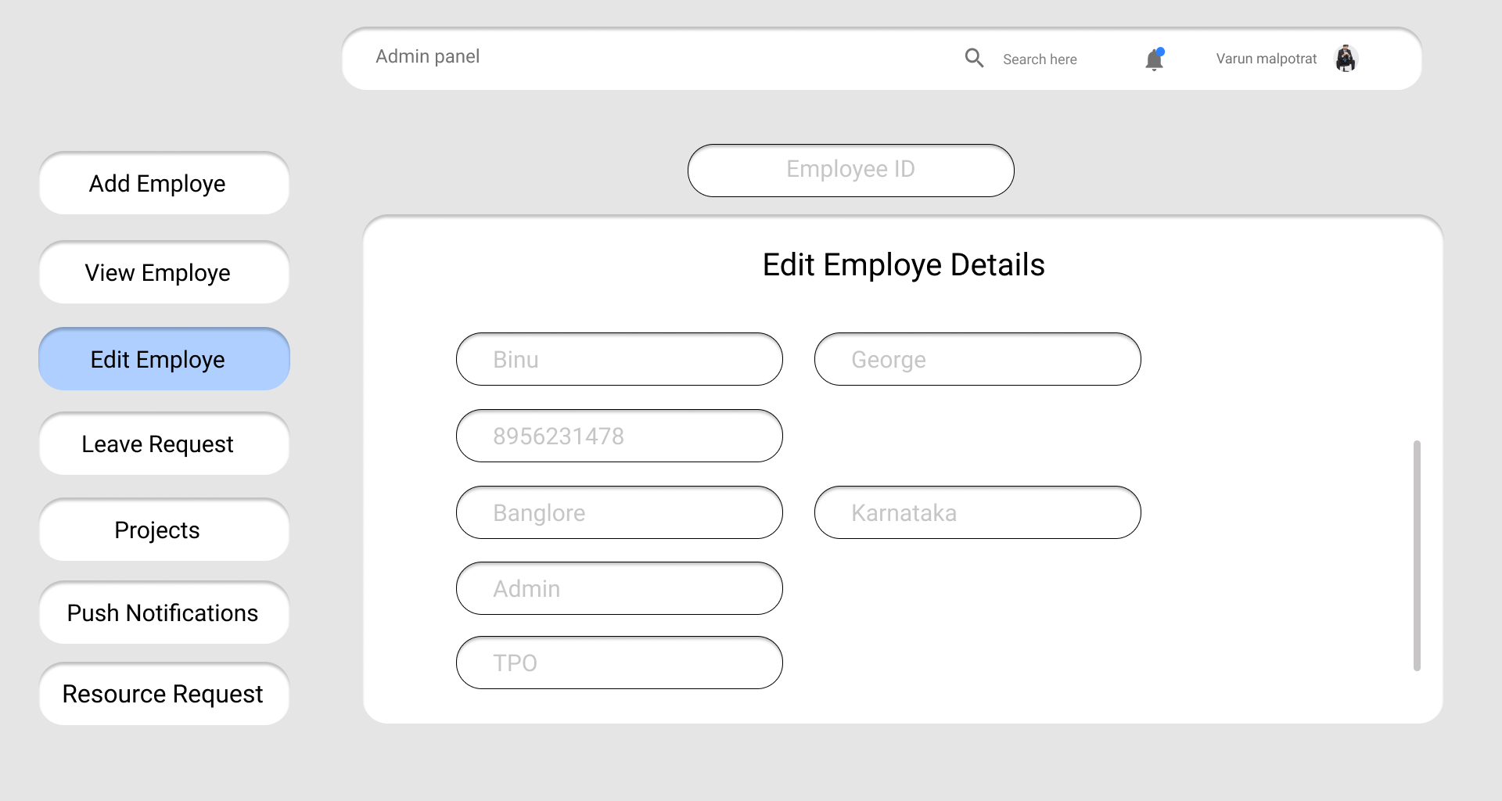

**A04:-** Admin can accept Or reject employee leave request.

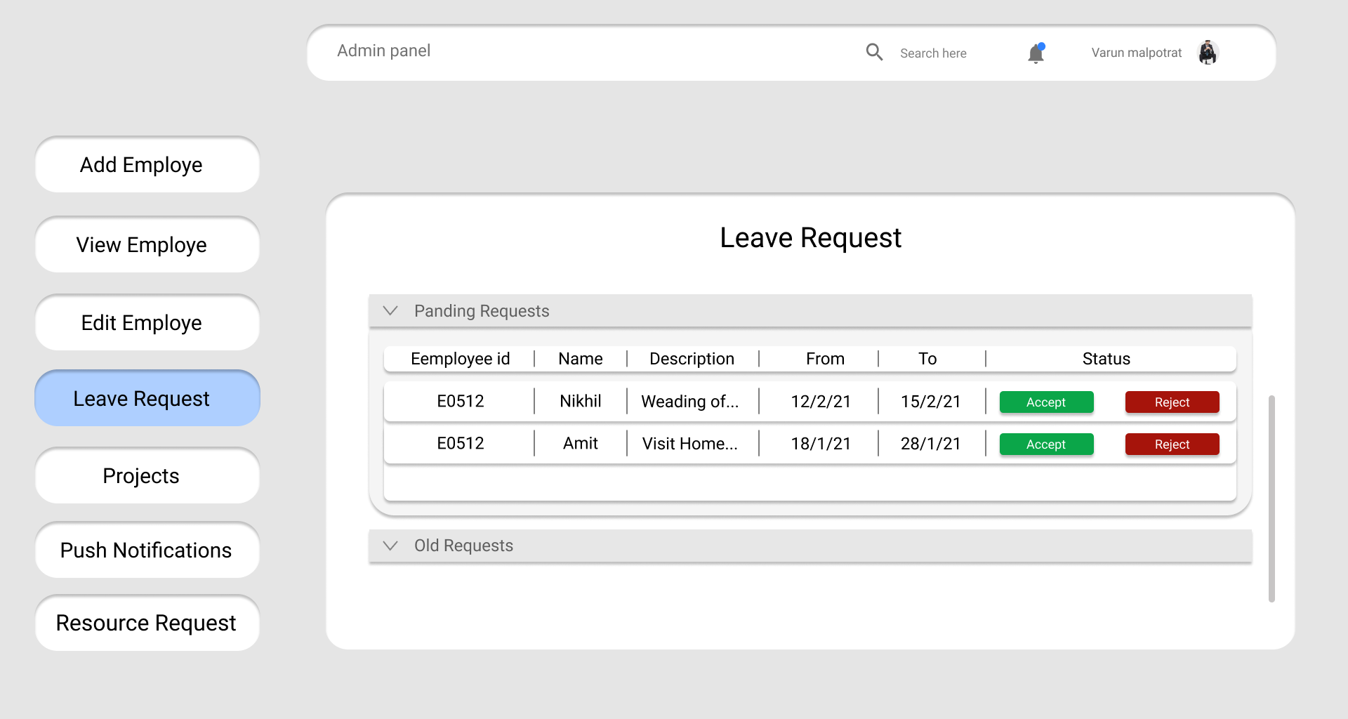

**A05(a):-** Admin can add new project and assign manager to it.

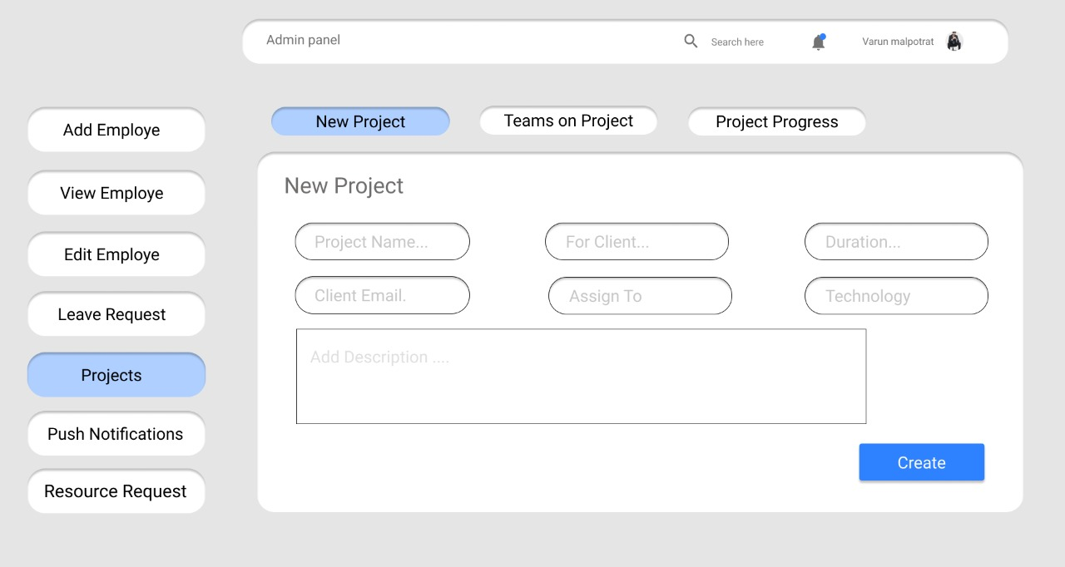

**A05(b):-** Admin can see on project team members details in this page and performance in percentage.

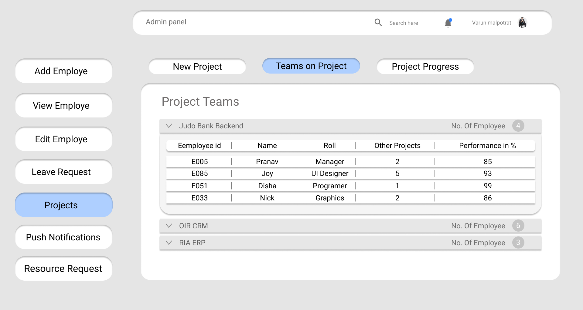

**A05(c):-** Admin can see project progress and active issues/completed issues.

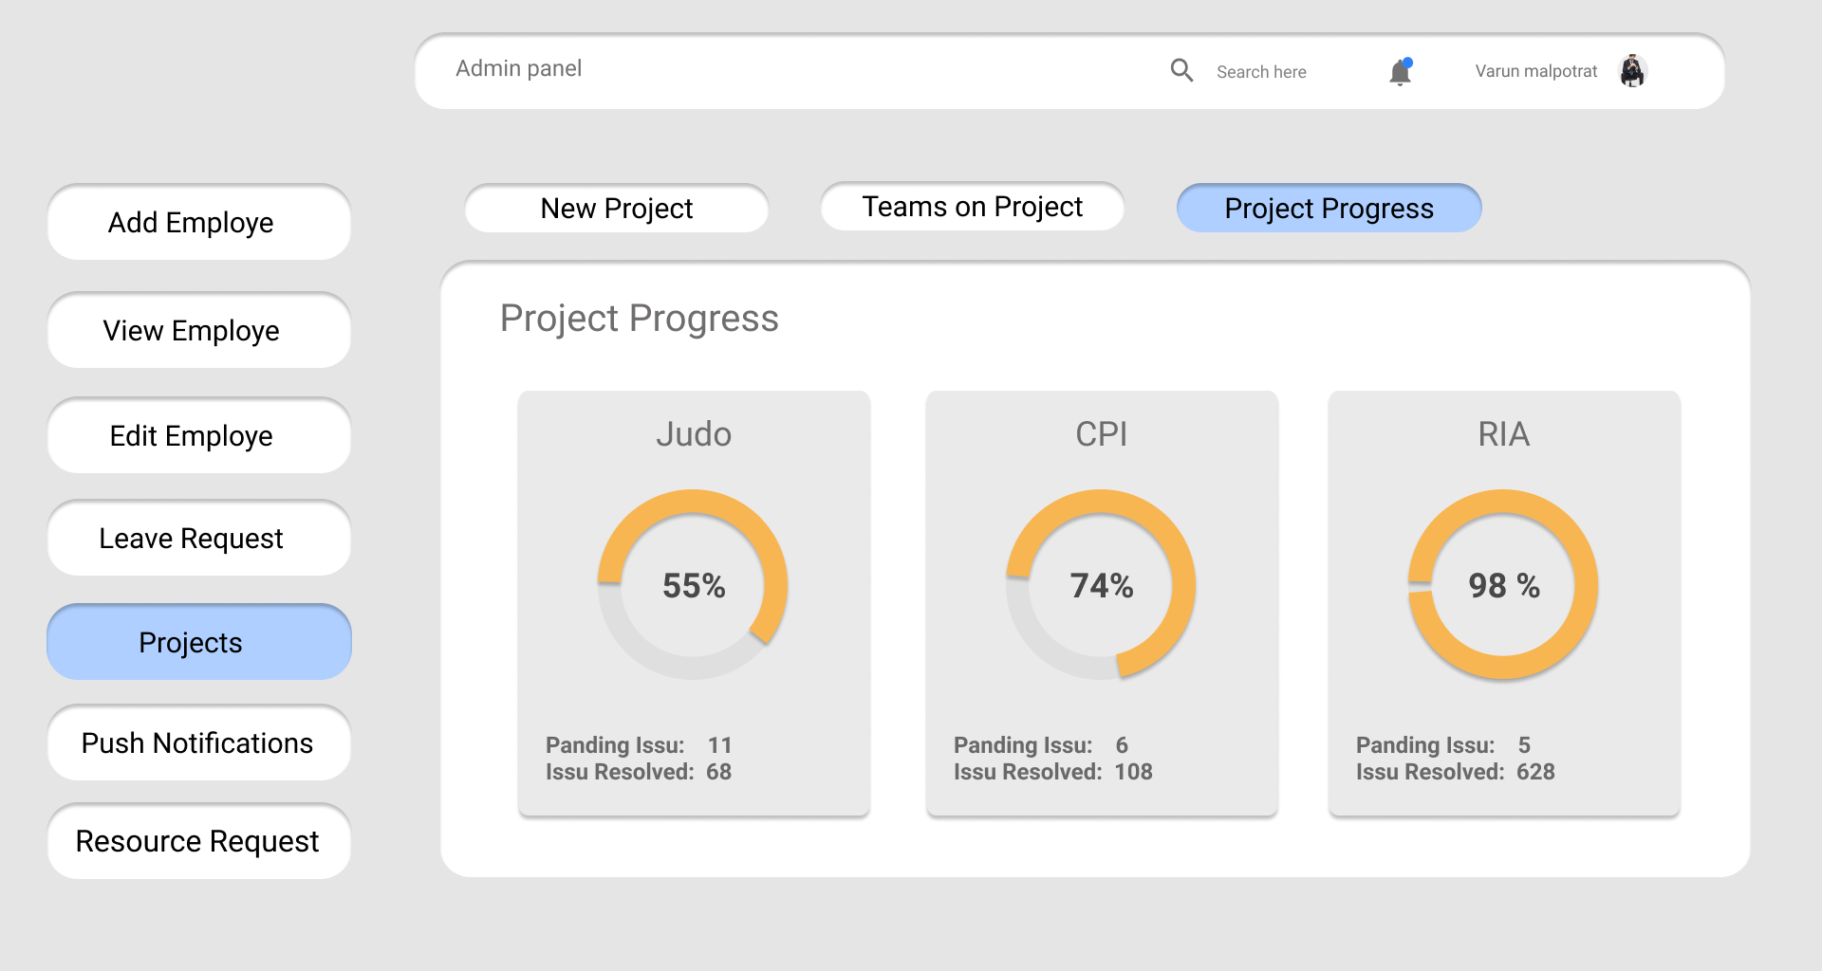

**A06:-** Admin can send push notification to all managers Or All employees need basis.

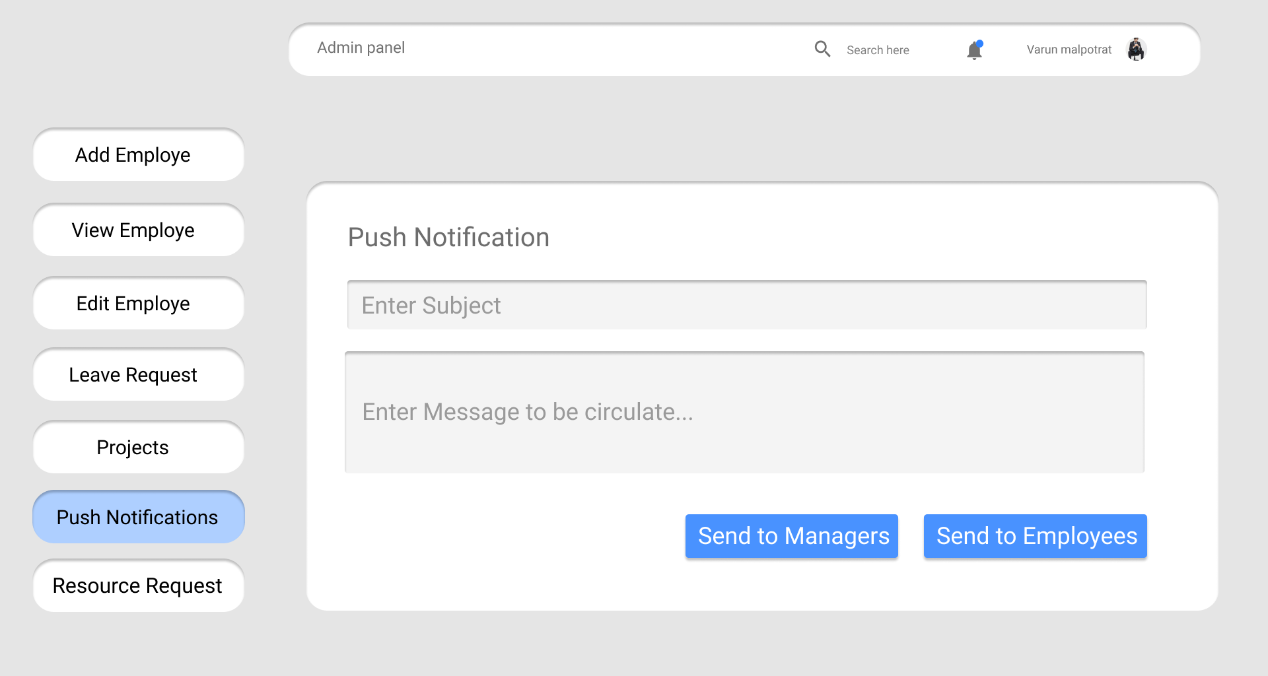

**A07:-** Admin can accept / reject resource request came from employees.

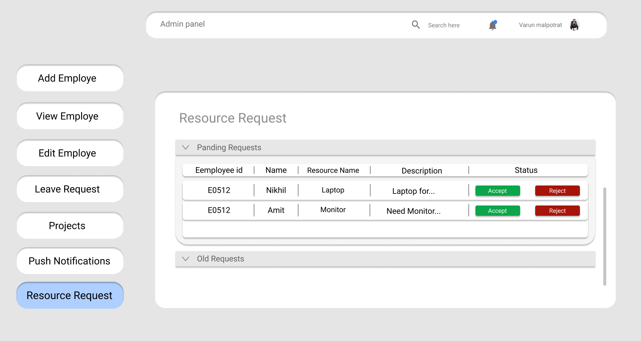

**2)Manager Page:**

**M01:-**Manager can see performance of team on dashboard.

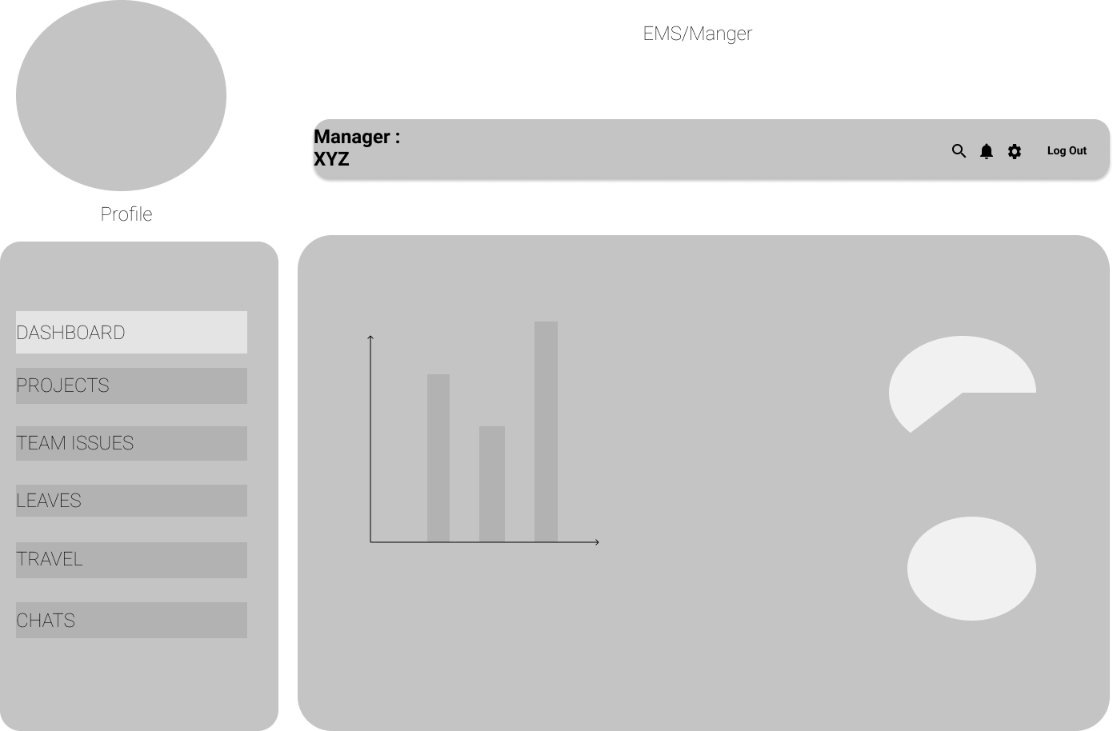

**M02:-**Manager can see all details about the projects.

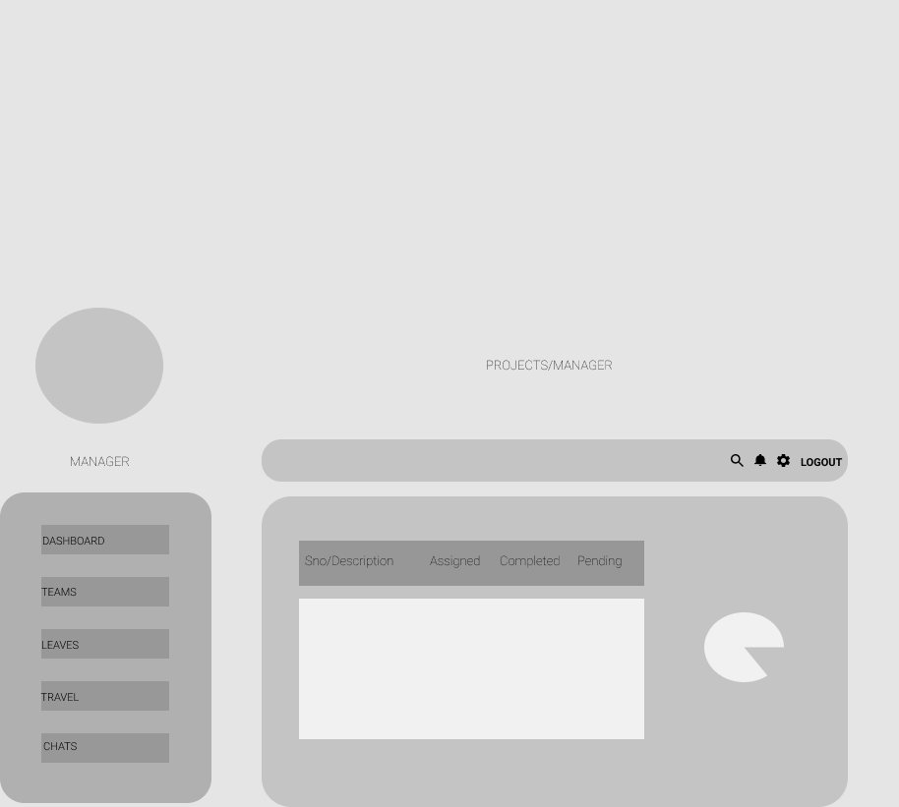

**M03:-**Manager can see leave request came from project team mates.

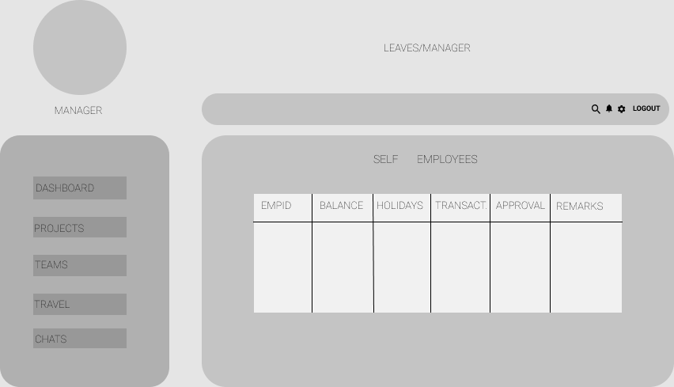

**M04:-**Manager can rise issues related to any project and assign team mates.

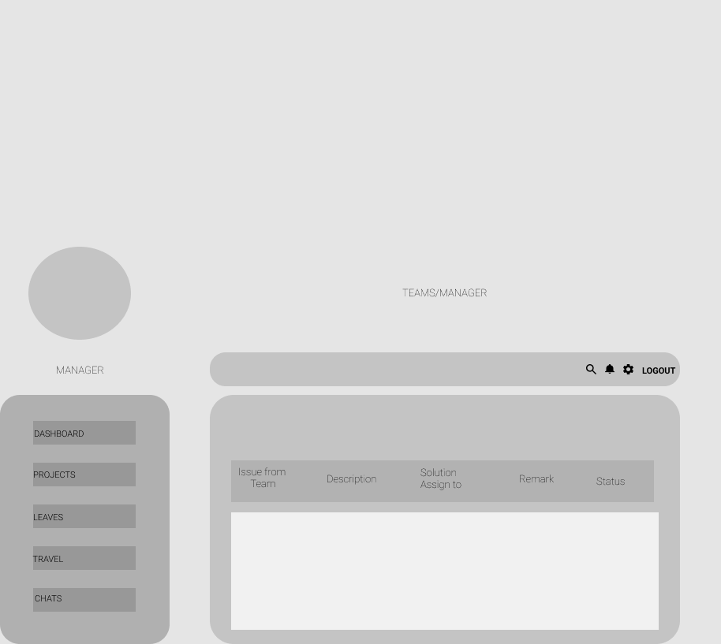

**3)Employee Page:**

**E01:-**Employee can see today’s task on dashboard.



**E02:-**Employee can see progress on issue.

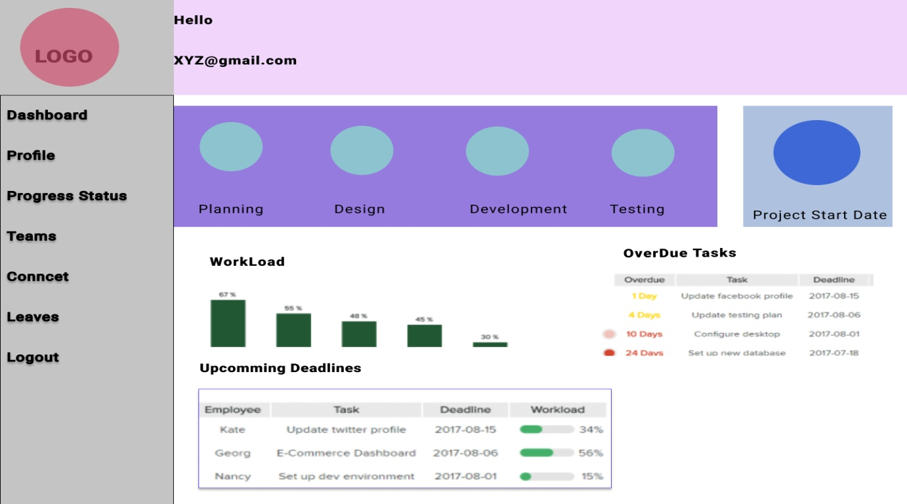

**E03:-**Employee can rise request for leave..

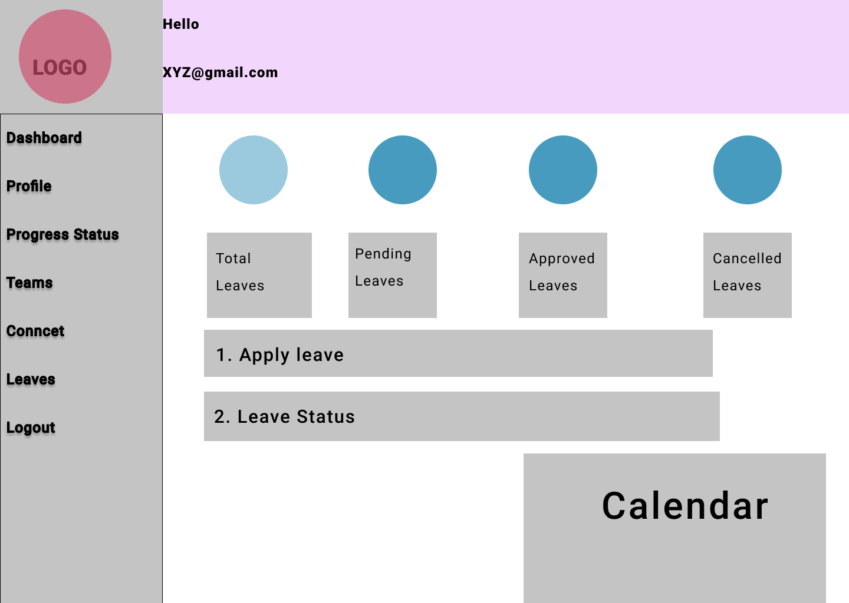

**E04:-**Employee can connect to other team members of projects.

